www.vicom-corp.com
866-448-4266

A Single-Source Solution Provider for All Your SD-WAN Service Needs

Software Defined WAN or SD-WAN is becoming the mainstream choice for many organizations. Does using Internet facing circuits instead of private circuits sound intimidating? It doesn't have to. Vicom Corporation partners with the world's leading SD-WAN providers, and can address concerns about security, redundancy, quality of experience, and more.

WHY CHOOSE SD- WAN?
- Best overall value and functionality
- Agility and speed when adding locations
- Redundancy, scalability and fault tolerance
- Quality of experience for critical applications
- Simplifcation of operations
- Connectivity to other cloud-based solutions
- Dynamic bandwidth
- Cost effective upgrades
- Support whenever you need it
- Application acceleration and optimization


Your business requires a robust communications and data network for its mission-critical applications and services. Traditionally, that has been accomplished by connecting private sites with MPLS or other private circuits. SD-WAN provides solutions that not only meet or exceed those offered by traditional WAN technologies, but can provide additional capabilities, such as redundancy, application acceleration, dynamic bandwidth to large cloud providers, and more. Map and scale to your business objectives faster and more effectively, with SD-WAN.

WHY WORK WITH US?
- Is independent & can deliver multiple options
- Will learn your business structure and goals
- Will understand your IT infrastructure
- Will determine the optimal SD-WAN solution
- Will research to source the optimal supplier
- Will implement and support the selected solution
- Post-implementation support, including customer service and escalations
- Be integrated as part of your organization's ecosystem

BANDWIDTH AGGREGATION

SD-WAN allows companies to utilize multiple Internet circuits, balance the load across them, and deliver a solid quality of experience.
Aggregating the Internet circuits allows for large amounts of bandwidth, while securely connecting to additional private locations. Additional sites can be added in very short order once Internet access is acquired.

REDUNDANCY

SD-WAN solutions can combine your MPLS and Internet connections so they don't sit idle. By dynamically and intelligently routing traffic over multiple circuits to improve efficiency, and providing seamless packet-by-packet routing to keep you up and running if there's a circuit failure, you and your employees can be more efficient and productive throughout the day.

SECURITY

Businesses appreciate the cost associated with Internet circuits but worry about security if transmitting sensitive data. SD-WAN provides secure connections between sites and reduced complexities - a benefit of as-a-Service solutions!

DYNAMIC BANDWIDTH

Do you utilize or plan to utilize other cloud services, such as AWS, Azure or Google? Many SD-WAN providers connect directly to many of these cloud providers. Additionally, there are options that allow bandwidth to grow dynamically as your cloud needs change.

QUALITY OF EXPERIENCE

SD-WAN solutions can provide prioritization to the mission critical applications your business demands.Typically, providers choose the best circuit based on real-time statistics in order to optimize the traffic, reduce overall latency, jitter and response times, and accelerate the applications themselves.

NETWORK FUNCTION VIRTUALIZATION
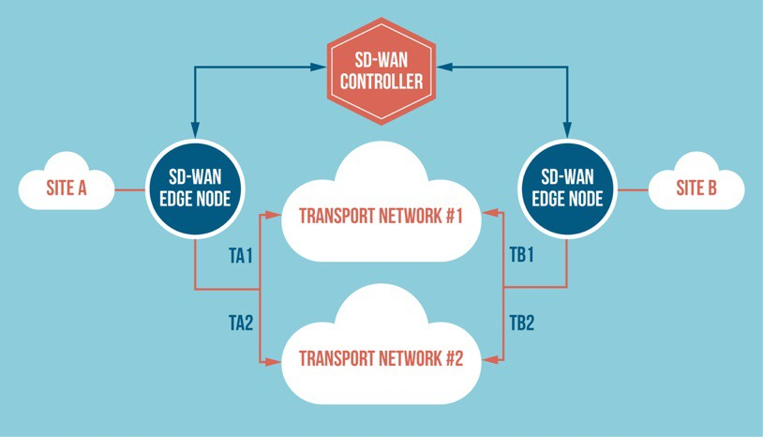
We can also provide partnerships with companies that can virtualize out many network functions, such as firewalls, VPNs, load balancing, application acceleration, etc.



Vicom Corporation www.vicom-corp.com
866-448-4266

ABOUT US
Vicom Corporation designs and delivers IT & communications solutions and services that help organizations execute on their strategic goals.

Our focus? Every business is unique, so we start with listening to the needs of our clients, and then exceed those needs in every way.

Contact us today to learn more about what SD-WAN services are right for your business.

